Selectboard Office
P.O. Box 317
Concord, VT 05824
(802)695-2910, ext.21
(802)284-2009

Bill Humphrey-Chairman
Chris Fournier-Vice-Chairman
George Morehouse
Shannon Chapman
Denis LaMadeleine

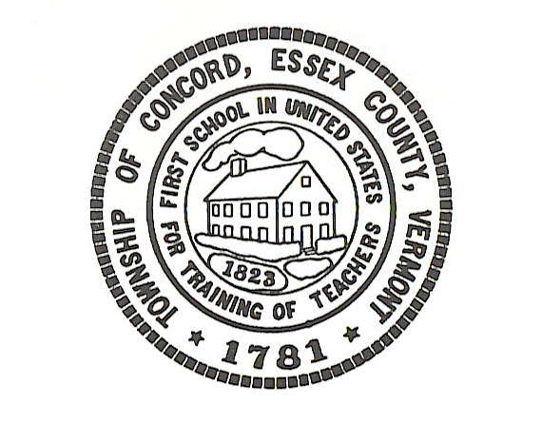

Concord Selectboard Special Meeting Agenda
Tuesday, September 26, 2023 @ 6:00pm
Municipal Building

Call to Order

Approval of Agenda

Cemetery Sexton Discussion

Proposal for Architectural Services

Town Garage Furnace Quote

Date for Zoning Administrator/E 911 Coordinator Interviews

Other

Executive Session: If discussion warrants, and the Board so votes, some items may be held in Executive Session.

Adjourn

Posted: September 21, 2023

